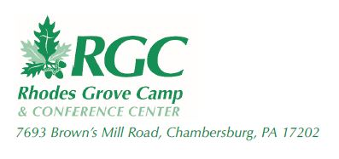
Re: Homeless Outreach in NYC

Dear ___________________,

This November, I have the opportunity to travel to New York City with other students in the 24/7 Leadership program of Rhodes Grove Camp & Conference Center, to minister to the homeless and less fortunate in NYC. This trip will include us helping distribute 5,000 turkey dinners throughout the 5 boroughs as well as street evangelism at selected spots throughout the city.
I know this will be challenging and out of my comfort zone but I am willing and ready to serve God! This trip will cost $250.00. I am attempting to raise ______ by October 31st 2018. Any amount will be greatly appreciated and 100% given will go to the cost of the trip. The cost includes transportation, food, lodging, and ministry materials we will use to communicate the Gospel. 100% of your donation is tax deductible and will generate a receipt by Rhodes Grove.
Please send all donations directly to RGC:
Rhodes Grove Camp & Conference Center
7693 Browns Mill Road
Chambersburg, PA 17202
Please include my name and 24/7 Missions Trip in the memo line.

Thank you for your consideration in partnering financially with me as I serve God through this trip!

In Christ,

