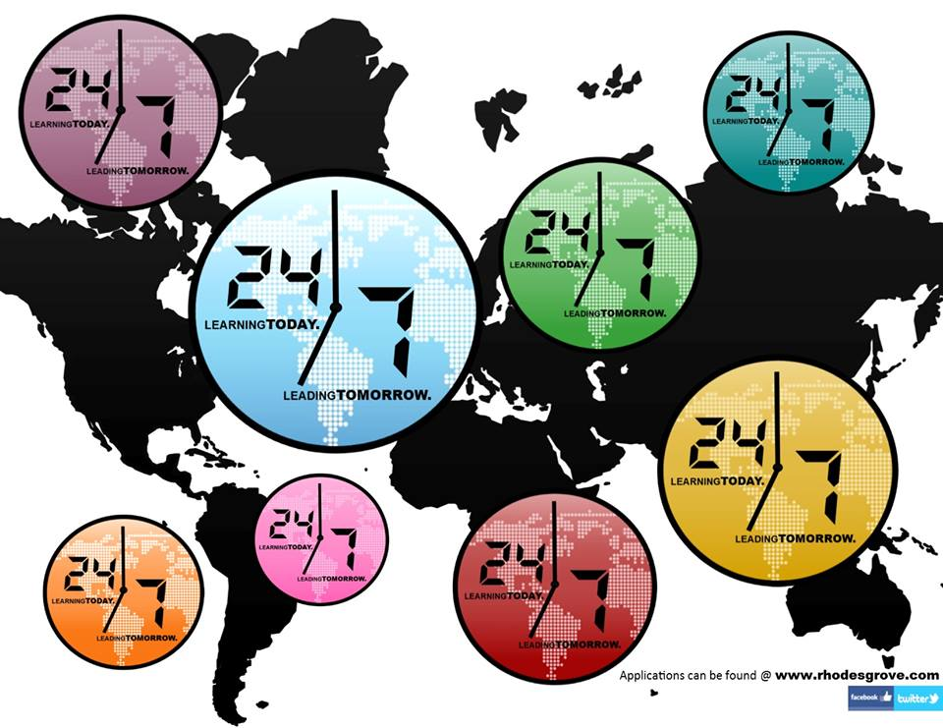

OPERATION

DRUMSTICK

PRAYER JOURNAL
[Company Name]
  - [Subtitle]

Main Points
- Pray For The Saints
- Be Unified with All Believers
- Be A Spiritual Ligament
- Be Imitators of God
- Put on the Full Armor of God so
you Can stand in your Faith

*Write Two things you learned
That you can share With the
Group About this Lesson
____________________________________
____________________________________
____________________________________
____________________________________
____________________________________
____________________________________
____________________________________
____________________________________
____________________________________

5

Day 3 - Sunday Nov 11th, 2018  Be Imitators of Christ  Start Your Sunday in prayer today. Give Thanks for the Lives that have been touched through the ministry in NYC this weekend. Also Pray for YOUR Church Leadership and Church Family today  Read: Ephesians 5:1-21  Journal: What does it mean to Imitate? What are some Characteristics of Jesus?  Read: Ephesians 6:10-18  Write: Write the 6 Pieces of Armor from this passage  Journal: Which Piece of Armor sticks out the most to you? Why? How can you “arm yourself” with these pieces?  Write: Ephesians 6:18  Pray:  Pray for the Saints from Your Day 1 list  Pray for all the things you are Thankful for Today  Pray about your sins and ask God to replace them with the Armor of God |  |  | God’s Word In Focus  Pray  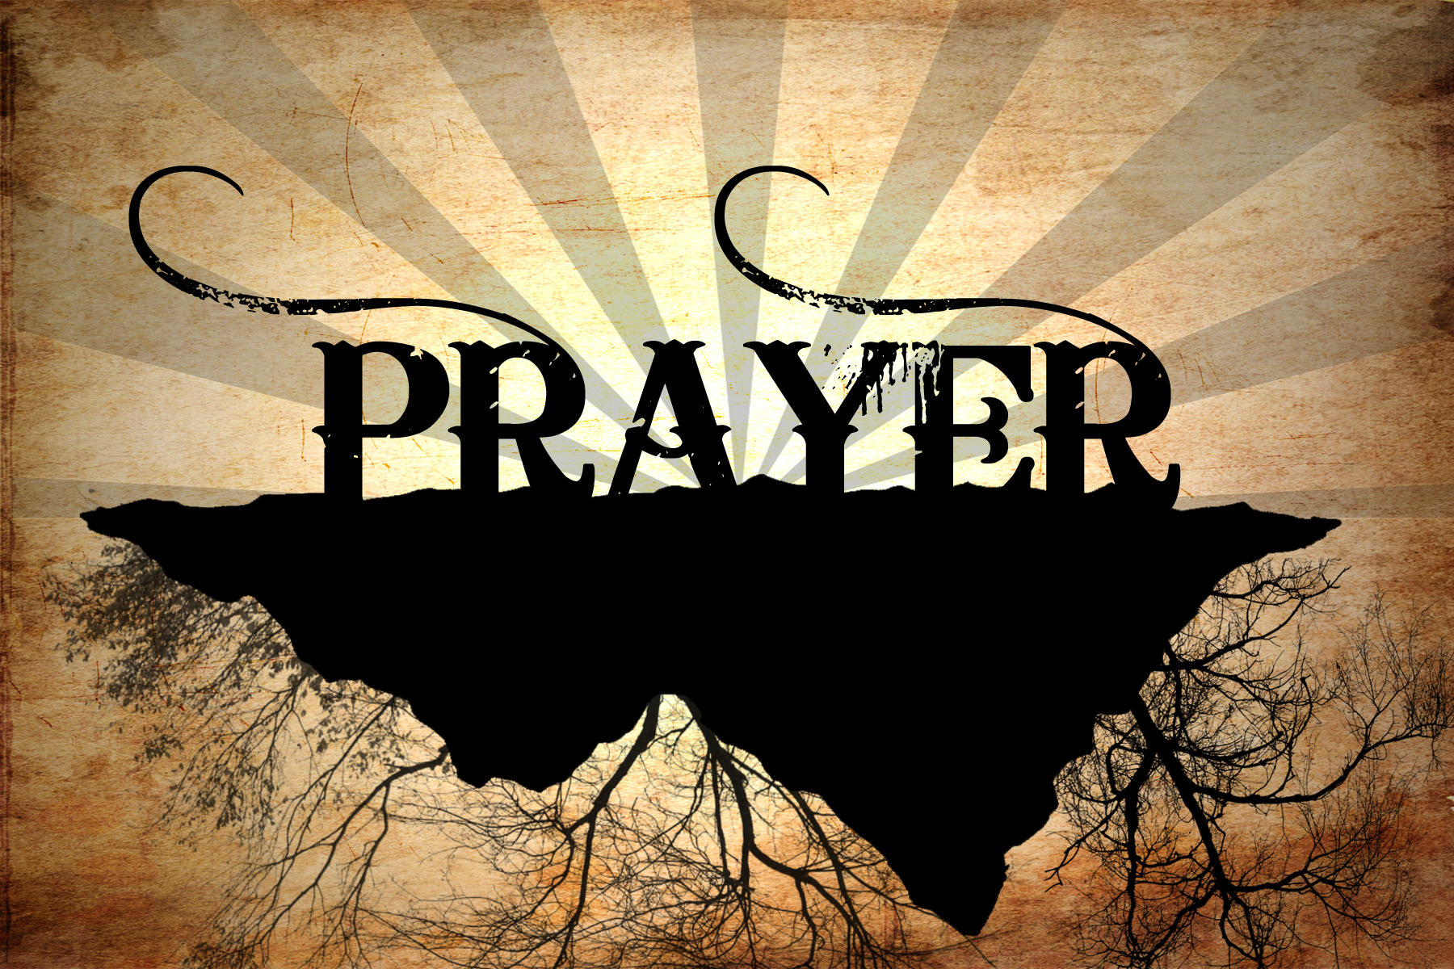 Use Each day to Lift up the 24/7 Team in NYC as they serve 5000 Turkey Dinners  Read  Continue meditating and reading Ephesians. There is always new knowledge and understanding to be learned through the LIVING word.  Journal  Journaling is one way to not only get your thoughts on paper and also one way God may choose to speak to you. It is also a great way to go back and remember your thoughts and what you have learned.
4 |  |  | 1

Day 1 – Friday Nov 9th 2018  Thanksgiving and Encouragement  Paul Starts out His letter to the Church of Ephesus with Blessing and Thanksgiving. Start this assignment in Prayer Today. Thank God for the blessings in your life and For the Team serving in NYC  Write: Ephesians 1:15&16 in your journals  Journal: What Are some Feelings or Apprehensions that You would have entering a new Mission field/ Ministry opportunity?  Journal: Who are other “Saints” that you may pray for regularly? Missionaries? Pastors or other Church Leadership? Your Camp Counselors? Make a list that you can pray for often.  Facts:  *There are 10 million People living in NYC  *100,000+ Are Homeless Living In NYC  *24/7 Leadership will be Handing out much needed supplies as well as sharing about Jesus to all kinds of people this evening  Pray:  Pray for Physical Safety  Pray For Doubts to be erased  Pray for Saving Grace to be received  Pray for Spiritual Growth within the Team  Pray for your List of Saints  Focus on What You Do Best  If you’re using this booklet for a company brochure, these middle pages are a good place for a summary of competitive benefits or some of those glowing testimonials, like the one above.  You might also want to mention a few of your most impressive clients here:  - Big, important company  - Really well-known company  - Very impressive company  Additionally, you could include a bulleted list of products, services, or major benefits of working with your company. Or just summarize your finer points in a few concise paragraphs. |  |  | Day 2- Saturday Nov 10th, 2018  UNITY in the Body of Christ  Paul Writes in Ephesians 4 that he Urges us to live a life worthy of the calling you have received  Think: Have you Received a Calling? Does a Calling have to Be specific? How can we be Unified as The Body of Christ? Write Down your thoughts  Read: Ephesians 4: 1-16  Write: Ephesians 4:14-16  Journal:  How is praying for the NYC trip being a “Supporting Ligament?”  How Does Unity in the Body of Christ relate to Leadership?  Spend some time in Prayer today meditating on the thought that you are a supporting ligament  Pray:  Continued Safety for the NYC Team  Growth for all 24/7 Leadership Students  New Thoughts On what attributes a leader possess  Divine Appointments  Pray for your List of Saints from Day 1
2 |  |  | 3

